1.Write a Terraform script to create a VPC with public and private subnets.
Task 1 — Create a VPC with Public and Private Subnets
Requirement
Write a Terraform script to create a VPC with public and private subnets.
We will create a realistic AWS architecture:
AWS VPC
10.0.0.0/16
|
+------------+------------+
| |
Public Subnets Private Subnets
| |
10.0.1.0/24 10.0.3.0/24
10.0.2.0/24 10.0.4.0/24
| |
Internet Gateway NAT Gateway
| |
Internet Internet
We'll use 2 Availability Zones for better availability.

Step 1 — Create the project folder
Since you're using VS Code on Windows, create:
D:\Terraform\task-01-vpc
Open that folder in VS Code.
Your folder should initially be:
task-01-vpc

Step 2 — Create Terraform files
Create these 4 files:
task-01-vpc/
│
├── provider.tf
├── variables.tf
├── main.tf
└── outputs.tf
We'll keep the first task simple rather than putting everything into one huge file.

Step 3 — Create provider.tf
Put this inside provider.tf:
terraform {
required_version = ">= 1.5.0"

required_providers {
aws = {
source = "hashicorp/aws"
version = "~> 6.0"
}
}
}

provider "aws" {
region = var.aws_region
}
What this does
Terraform needs the AWS provider to communicate with AWS.
provider "aws"
means:
Terraform, use AWS to create my infrastructure.
We're getting the region from:
var.aws_region

Step 4 — Create variables.tf
Put this inside:
variable "aws_region" {
description = "AWS region"
type = string
default = "ap-south-1"
}

variable "vpc_cidr" {
description = "CIDR block for VPC"
type = string
default = "10.0.0.0/16"
}

variable "public_subnet_1_cidr" {
description = "CIDR for public subnet 1"
type = string
default = "10.0.1.0/24"
}

variable "public_subnet_2_cidr" {
description = "CIDR for public subnet 2"
type = string
default = "10.0.2.0/24"
}

variable "private_subnet_1_cidr" {
description = "CIDR for private subnet 1"
type = string
default = "10.0.3.0/24"
}

variable "private_subnet_2_cidr" {
description = "CIDR for private subnet 2"
type = string
default = "10.0.4.0/24"
}

Step 5 — Create main.tf
Now the main infrastructure.
5.1 Create the VPC
Add:
resource "aws_vpc" "main" {
cidr_block = var.vpc_cidr
enable_dns_support = true
enable_dns_hostnames = true

tags = {
Name = "task-01-vpc"
}
}
This creates:
VPC
10.0.0.0/16

Step 6 — Create Public Subnet 1
Add:
resource "aws_subnet" "public_1" {
vpc_id = aws_vpc.main.id
cidr_block = var.public_subnet_1_cidr
availability_zone = "ap-south-1a"
map_public_ip_on_launch = true

tags = {
Name = "task-01-public-subnet-1"
}
}

Step 7 — Create Public Subnet 2
resource "aws_subnet" "public_2" {
vpc_id = aws_vpc.main.id
cidr_block = var.public_subnet_2_cidr
availability_zone = "ap-south-1b"
map_public_ip_on_launch = true

tags = {
Name = "task-01-public-subnet-2"
}
}

Step 8 — Create Private Subnet 1
resource "aws_subnet" "private_1" {
vpc_id = aws_vpc.main.id
cidr_block = var.private_subnet_1_cidr
availability_zone = "ap-south-1a"

tags = {
Name = "task-01-private-subnet-1"
}
}

Step 9 — Create Private Subnet 2
resource "aws_subnet" "private_2" {
vpc_id = aws_vpc.main.id
cidr_block = var.private_subnet_2_cidr
availability_zone = "ap-south-1b"

tags = {
Name = "task-01-private-subnet-2"
}
}

Step 10 — Create Internet Gateway
Public subnets need an Internet Gateway.
resource "aws_internet_gateway" "main" {
vpc_id = aws_vpc.main.id

tags = {
Name = "task-01-igw"
}
}
Architecture now:
Internet
|
|
Internet Gateway
|
|
VPC

Step 11 — Create Public Route Table
resource "aws_route_table" "public" {
vpc_id = aws_vpc.main.id

route {
cidr_block = "0.0.0.0/0"
gateway_id = aws_internet_gateway.main.id
}

tags = {
Name = "task-01-public-rt"
}
}
The important part is:
0.0.0.0/0
This means:
All internet traffic.

Step 12 — Associate Public Subnet 1
resource "aws_route_table_association" "public_1" {
subnet_id = aws_subnet.public_1.id
route_table_id = aws_route_table.public.id
}

Step 13 — Associate Public Subnet 2
resource "aws_route_table_association" "public_2" {
subnet_id = aws_subnet.public_2.id
route_table_id = aws_route_table.public.id
}
Now:
Public Subnet 1 ──┐
├── Public Route Table ── IGW ── Internet
Public Subnet 2 ──┘

Step 14 — Create Elastic IP for NAT Gateway
Private instances shouldn't directly receive public IPs.
For outbound internet access, we'll use NAT Gateway.
resource "aws_eip" "nat" {
domain = "vpc"

tags = {
Name = "task-01-nat-eip"
}
}

Step 15 — Create NAT Gateway
We'll put NAT Gateway in Public Subnet 1.
resource "aws_nat_gateway" "main" {
allocation_id = aws_eip.nat.id
subnet_id = aws_subnet.public_1.id

depends_on = [
aws_internet_gateway.main
]

tags = {
Name = "task-01-nat-gateway"
}
}
Notice:
depends_on
We're explicitly telling Terraform:
Create the Internet Gateway before creating the NAT Gateway.
We'll study depends_on properly in Task 13.

Step 16 — Create Private Route Table
resource "aws_route_table" "private" {
vpc_id = aws_vpc.main.id

route {
cidr_block = "0.0.0.0/0"
nat_gateway_id = aws_nat_gateway.main.id
}

tags = {
Name = "task-01-private-rt"
}
}
Traffic becomes:
Private EC2
|
Private Route Table
|
NAT Gateway
|
Internet Gateway
|
Internet
The private EC2 doesn't need a public IP.

Step 17 — Associate Private Subnet 1
resource "aws_route_table_association" "private_1" {
subnet_id = aws_subnet.private_1.id
route_table_id = aws_route_table.private.id
}

Step 18 — Associate Private Subnet 2
resource "aws_route_table_association" "private_2" {
subnet_id = aws_subnet.private_2.id
route_table_id = aws_route_table.private.id
}

Complete main.tf
Your final main.tf should look like this:
resource "aws_vpc" "main" {
cidr_block = var.vpc_cidr
enable_dns_support = true
enable_dns_hostnames = true

tags = {
Name = "task-01-vpc"
}
}

resource "aws_subnet" "public_1" {
vpc_id = aws_vpc.main.id
cidr_block = var.public_subnet_1_cidr
availability_zone = "ap-south-1a"
map_public_ip_on_launch = true

tags = {
Name = "task-01-public-subnet-1"
}
}

resource "aws_subnet" "public_2" {
vpc_id = aws_vpc.main.id
cidr_block = var.public_subnet_2_cidr
availability_zone = "ap-south-1b"
map_public_ip_on_launch = true

tags = {
Name = "task-01-public-subnet-2"
}
}

resource "aws_subnet" "private_1" {
vpc_id = aws_vpc.main.id
cidr_block = var.private_subnet_1_cidr
availability_zone = "ap-south-1a"

tags = {
Name = "task-01-private-subnet-1"
}
}

resource "aws_subnet" "private_2" {
vpc_id = aws_vpc.main.id
cidr_block = var.private_subnet_2_cidr
availability_zone = "ap-south-1b"

tags = {
Name = "task-01-private-subnet-2"
}
}

resource "aws_internet_gateway" "main" {
vpc_id = aws_vpc.main.id

tags = {
Name = "task-01-igw"
}
}

resource "aws_route_table" "public" {
vpc_id = aws_vpc.main.id

route {
cidr_block = "0.0.0.0/0"
gateway_id = aws_internet_gateway.main.id
}

tags = {
Name = "task-01-public-rt"
}
}

resource "aws_route_table_association" "public_1" {
subnet_id = aws_subnet.public_1.id
route_table_id = aws_route_table.public.id
}

resource "aws_route_table_association" "public_2" {
subnet_id = aws_subnet.public_2.id
route_table_id = aws_route_table.public.id
}

resource "aws_eip" "nat" {
domain = "vpc"

tags = {
Name = "task-01-nat-eip"
}
}

resource "aws_nat_gateway" "main" {
allocation_id = aws_eip.nat.id
subnet_id = aws_subnet.public_1.id

depends_on = [
aws_internet_gateway.main
]

tags = {
Name = "task-01-nat-gateway"
}
}

resource "aws_route_table" "private" {
vpc_id = aws_vpc.main.id

route {
cidr_block = "0.0.0.0/0"
nat_gateway_id = aws_nat_gateway.main.id
}

tags = {
Name = "task-01-private-rt"
}
}

resource "aws_route_table_association" "private_1" {
subnet_id = aws_subnet.private_1.id
route_table_id = aws_route_table.private.id
}

resource "aws_route_table_association" "private_2" {
subnet_id = aws_subnet.private_2.id
route_table_id = aws_route_table.private.id
}

Step 19 — Create outputs.tf
Add:
output "vpc_id" {
description = "VPC ID"
value = aws_vpc.main.id
}

output "public_subnet_ids" {
description = "Public subnet IDs"
value = [
aws_subnet.public_1.id,
aws_subnet.public_2.id
]
}

output "private_subnet_ids" {
description = "Private subnet IDs"
value = [
aws_subnet.private_1.id,
aws_subnet.private_2.id
]
}

output "internet_gateway_id" {
description = "Internet Gateway ID"
value = aws_internet_gateway.main.id
}

output "nat_gateway_id" {
description = "NAT Gateway ID"
value = aws_nat_gateway.main.id
}

Step 20 — Check your folder
You should now have:
task-01-vpc
│
├── provider.tf
├── variables.tf
├── main.tf
└── outputs.tf

Step 21 — Configure AWS credentials
Since you already configured AWS CLI previously, first verify:
aws sts get-caller-identity
You should get your AWS account information.
Also check:
aws configure list
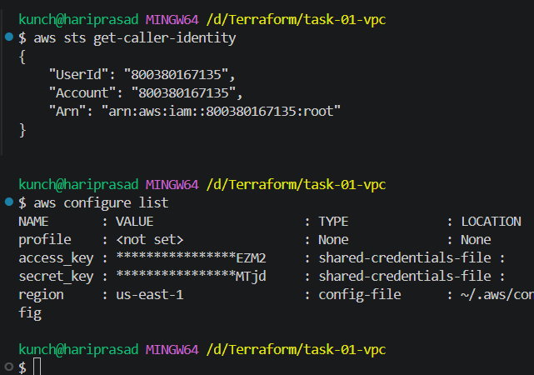

Step 22 — Terraform Initialize
Open VS Code terminal:
cd D:\Terraform\task-01-vpc
Then:
terraform init
Expected:
Terraform has been successfully initialized!
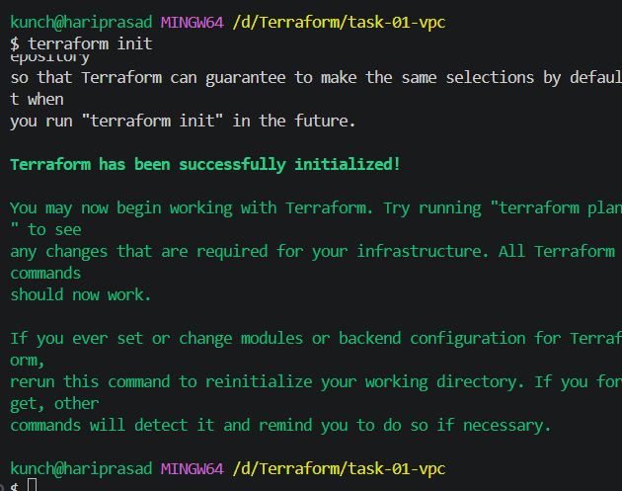

Step 23 — Format Terraform
Run:
terraform fmt
Then:
terraform validate
Expected:
Success! The configuration is valid.
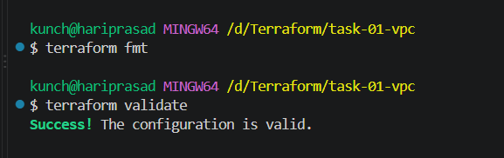

Step 24 — Run Terraform Plan
Now:
terraform plan
Terraform will show what it intends to create.
Approximately:
Plan: 13 to add, 0 to change, 0 to destroy.
The exact count can vary with provider/resource behavior, so focus on the resources listed rather than the number.
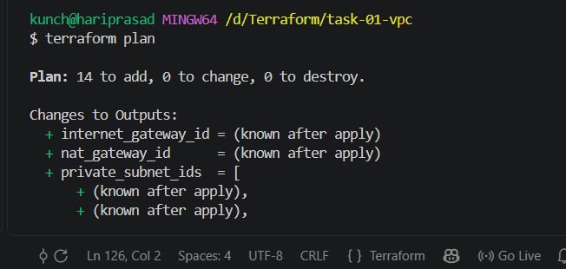

Step 25 — Apply
Now:
terraform apply
Terraform asks:
Do you want to perform these actions?
Enter a value:
Type:
yes
Terraform will create:
VPC
├── Public Subnet 1
├── Public Subnet 2
├── Private Subnet 1
├── Private Subnet 2
├── Internet Gateway
├── Public Route Table
├── Private Route Table
├── NAT Gateway
├── Elastic IP
└── Route Table Associations

Step 26 — Check outputs
Run:
terraform output
You should see something similar to:
internet_gateway_id = "igw-xxxxxxxx"
nat_gateway_id = "nat-xxxxxxxx"
private_subnet_ids = [
"subnet-xxxxxxxx",
"subnet-yyyyyyyy"
]
public_subnet_ids = [
"subnet-aaaaaaaa",
"subnet-bbbbbbbb"
]
vpc_id = "vpc-xxxxxxxx"
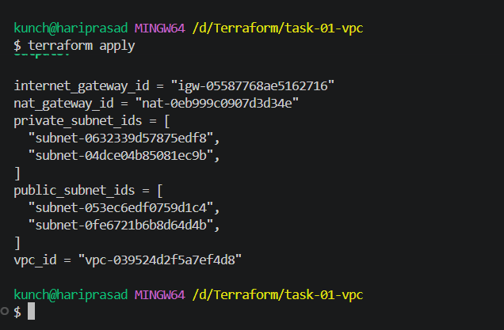

Step 27 — Verify from AWS Console
Go to:
AWS Console → VPC → Your VPCs
Find:
task-01-vpc
Then check:
Subnets
You should see:
task-01-public-subnet-1
task-01-public-subnet-2
task-01-private-subnet-1
task-01-private-subnet-2
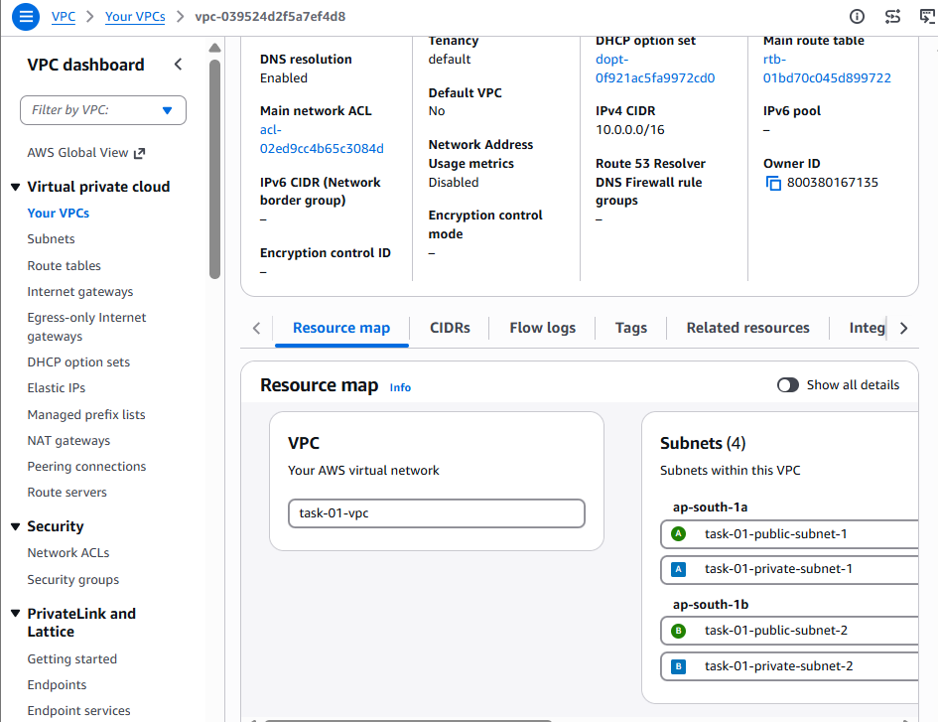
Internet Gateway
You should see:
task-01-igw
attached to your VPC.
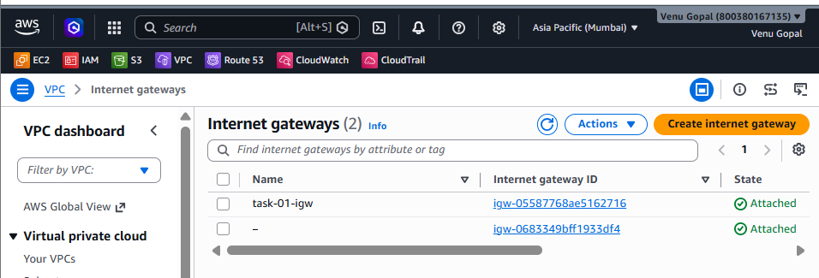
NAT Gateway
You should see:
task-01-nat-gateway
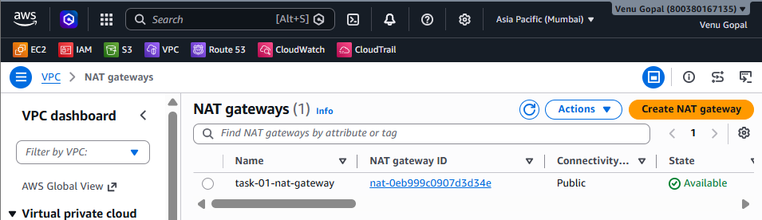

🧠 Understand the architecture
This is the important part for interviews.
Public subnet
A subnet is considered public because its route table has:
0.0.0.0/0 → Internet Gateway
Example:
EC2
|
Public Subnet
|
Route Table
|
IGW
|
Internet

Private subnet
Private subnet has:
0.0.0.0/0 → NAT Gateway
Example:
EC2
|
Private Subnet
|
Private Route Table
|
NAT Gateway
|
Internet Gateway
|
Internet
The private EC2 can initiate outbound connections through NAT, but it isn't directly reachable from the internet through the NAT gateway.

⭐ Important interview point
If interviewer asks:
What makes a subnet public?
Don't say:
"Because we assign a public IP."
That's incomplete.
Say:
A subnet is considered public when its associated route table contains a route to an Internet Gateway, typically 0.0.0.0/0 → IGW. A public IP is required for an instance to communicate directly over the internet, but the subnet's routing determines whether it is public or private.

Step 28 — Check Terraform State
Run:
terraform show
This shows the infrastructure Terraform is managing.
Also:
dir
You will see:
.terraform
.terraform.lock.hcl
terraform.tfstate
main.tf
outputs.tf
provider.tf
variables.tf
Do not manually edit terraform.tfstate.
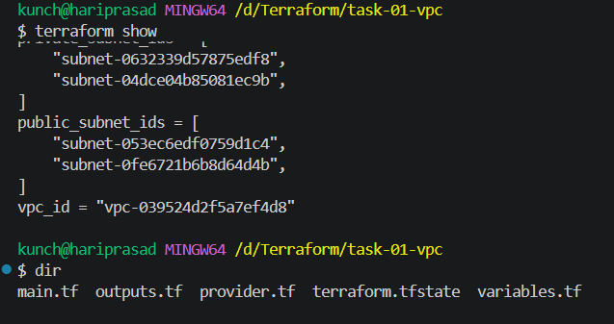

Step 29 — Destroy the infrastructure
Because NAT Gateway can incur AWS charges, don't leave this lab running unnecessarily.
Run:
terraform destroy
Then:
Do you want to destroy all of these resources?
Type:
yes
Verify in AWS that the VPC and related resources are gone.

2.Write a Terraform script to create an EC2 instance and attach an existing EBS volume.
Requirement
Write a Terraform script to create an EC2 instance and attach an existing EBS volume.
For this task, we'll assume the EBS volume already exists in AWS. Terraform will:
- Look up the existing EBS volume.
- Create a new EC2 instance.
- Attach the existing EBS volume to the EC2 instance.
- Output the EC2 and EBS IDs.
Architecture
AWS
│
├── Existing EBS Volume
│ │
│ │ attach
│ ▼
└── EC2 Instance
│
└── /dev/sdf
⚠️ Very important
An EBS volume can be attached to an EC2 instance only when both are in the same Availability Zone.
For example:
EC2 → ap-south-1a
EBS → ap-south-1a
✅ Works
But:
EC2 → ap-south-1a
EBS → ap-south-1b
❌ Cannot attach
So we'll deliberately use the EBS volume's AZ when creating the EC2.

Step 1 — Create folder
In your Terraform directory:
D:\Terraform
Create:
task-02-ec2-ebs
Open it in VS Code.
Folder:
task-02-ec2-ebs/
│
├── provider.tf
├── variables.tf
├── main.tf
└── outputs.tf

Create EC2 and attach an existing EBS volume
We will use:
- Existing EBS: vol-0bafaf4dcf5140e03
- Size: 8 GiB
- AZ: ap-south-1b
- Region: ap-south-1
- Instance type: t3.micro
- Device: /dev/sdf
1. Create a folder in VS Code
Use this folder name:
terraform-ec2-existing-ebs
Inside it create:
terraform-ec2-existing-ebs/
├── provider.tf
├── variables.tf
├── main.tf
└── outputs.tf
2. provider.tf
terraform {
required_providers {
aws = {
source = "hashicorp/aws"
}
}
}

provider "aws" {
region = "ap-south-1"
}
3. variables.tf
variable "ami_id" {
description = "Amazon Linux 2023 AMI"
type = string
default = "ami-0f918f7e67a3323f0"
}

variable "instance_type" {
description = "EC2 instance type"
type = string
default = "t3.micro"
}

variable "availability_zone" {
description = "Availability Zone"
type = string
default = "ap-south-1b"
}

variable "existing_volume_id" {
description = "Existing EBS volume ID"
type = string
default = "vol-0bafaf4dcf5140e03"
}
4. main.tf
resource "aws_instance" "ec2" {
ami = var.ami_id
instance_type = var.instance_type
availability_zone = var.availability_zone

tags = {
Name = "Terraform-EC2-Existing-EBS"
}
}

resource "aws_volume_attachment" "ebs_attachment" {
device_name = "/dev/sdf"
volume_id = var.existing_volume_id
instance_id = aws_instance.ec2.id
}
5. outputs.tf
output "instance_id" {
value = aws_instance.ec2.id
}

output "instance_public_ip" {
value = aws_instance.ec2.public_ip
}

output "attached_volume_id" {
value = aws_volume_attachment.ebs_attachment.volume_id
}

output "availability_zone" {
value = aws_instance.ec2.availability_zone
}
6. Run Terraform
Open the VS Code terminal inside this folder.
Run:
terraform init
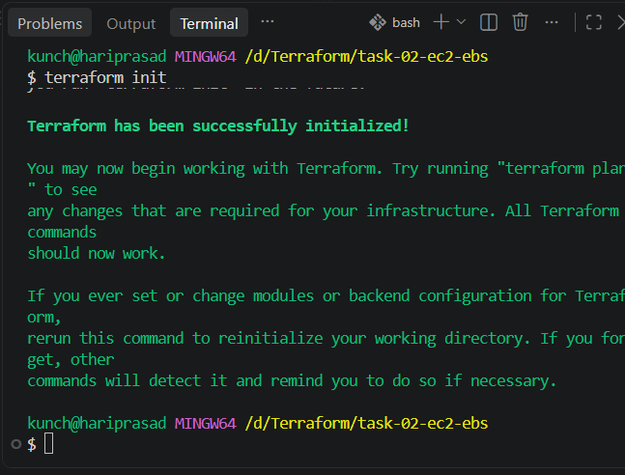
Then:
terraform fmt
Then:
terraform validate
You should get:
Success! The configuration is valid.
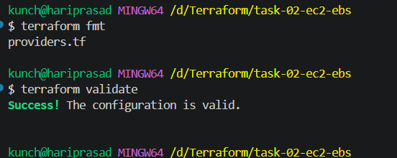
Now:
terraform plan
Check that Terraform wants to create:
aws_instance.ec2
aws_volume_attachment.ebs_attachment
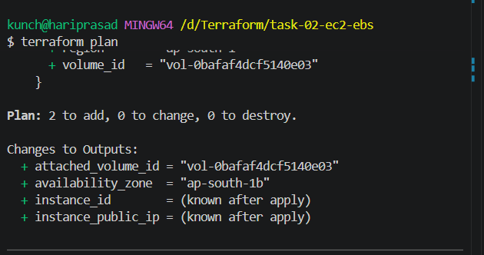
Then:
terraform apply
Enter:
Yes
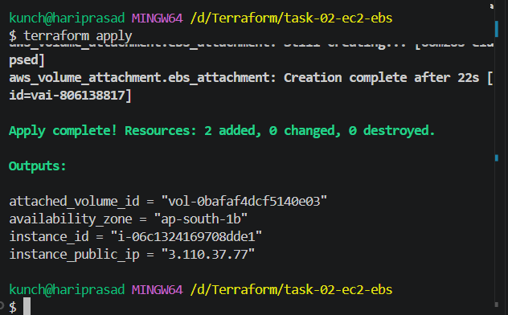
7. Verify in AWS
After apply completes, go to:
EC2 → Instances
You should see:
Terraform-EC2-Existing-EBS
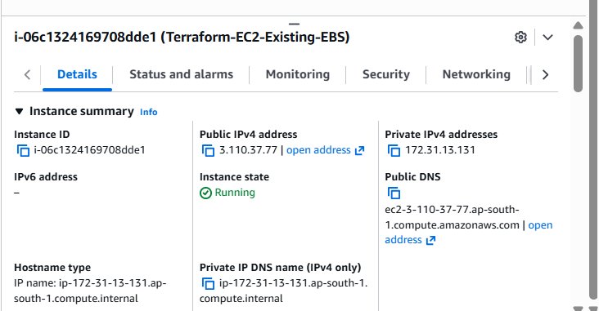
Then go to:
EC2 → Volumes
Your existing volume:
vol-0bafaf4dcf5140e03
should now show:
In-use
and attached to your new instance.
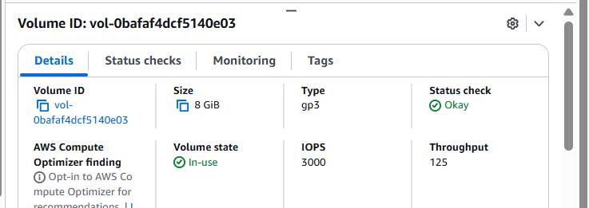

3.Write a Terraform script to create an EC2 instance with a Security Group using Terraform.
We’ll create:
- EC2 instance
- Security Group
- Allow SSH (22)
- Allow HTTP (80)
- Attach the Security Group to EC2
- Use Amazon Linux 2023
- Region: ap-south-1 (Mumbai)
Step 1 — Create the folder
In VS Code:
D:\Terraform\task-03-ec2-security-group
Open this folder in VS Code.
Create these 4 files:
task-03-ec2-security-group/
│
├── provider.tf
├── variables.tf
├── security-group.tf
└── ec2.tf
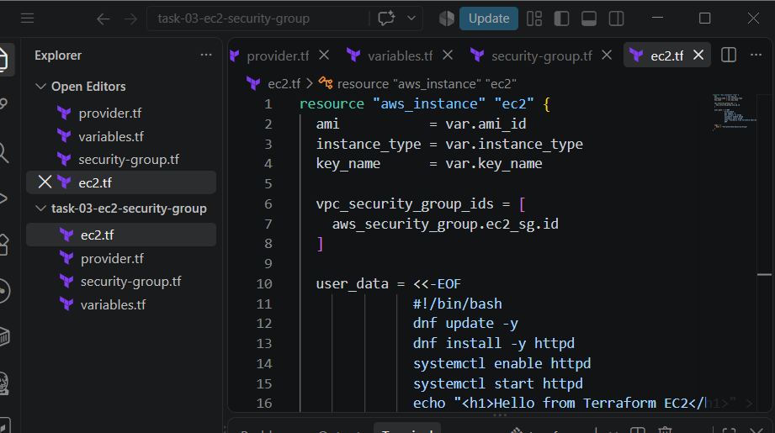

Step 2 — provider.tf
Paste:
terraform {
required_providers {
aws = {
source = "hashicorp/aws"
}
}
}

provider "aws" {
region = "ap-south-1"
}

Step 3 — variables.tf
Paste:
variable "ami_id" {
description = "Amazon Linux 2023 AMI"
type = string
default = "ami-0f918f7e67a3323f0"
}

variable "instance_type" {
description = "EC2 instance type"
type = string
default = "t3.micro"
}

variable "key_name" {
description = "Existing EC2 key pair name"
type = string
default = "docker-practice-key"
}
⚠️ Important: If your actual AWS key pair has a different name, change:
default = "docker-practice-key"
to your actual key-pair name.

Step 4 — Create security-group.tf
Paste:
resource "aws_security_group" "ec2_sg" {
name = "terraform-ec2-sg"
description = "Security group for Terraform EC2 instance"

ingress {
description = "SSH"
from_port = 22
to_port = 22
protocol = "tcp"
cidr_blocks = ["0.0.0.0/0"]
}

ingress {
description = "HTTP"
from_port = 80
to_port = 80
protocol = "tcp"
cidr_blocks = ["0.0.0.0/0"]
}

egress {
from_port = 0
to_port = 0
protocol = "-1"
cidr_blocks = ["0.0.0.0/0"]
}

tags = {
Name = "Terraform-EC2-SG"
}
}
What this does
SSH:
Port 22 → allowed
HTTP:
Port 80 → allowed
Outbound:
All traffic → allowed
For a learning lab, 0.0.0.0/0 is okay. In a real production environment, SSH should generally be restricted to trusted IP ranges.

Step 5 — Create ec2.tf
Paste:
resource "aws_instance" "ec2" {
ami = var.ami_id
instance_type = var.instance_type
key_name = var.key_name

vpc_security_group_ids = [
aws_security_group.ec2_sg.id
]

user_data = <<-EOF
#!/bin/bash
dnf update -y
dnf install -y httpd
systemctl enable httpd
systemctl start httpd
echo "<h1>Hello from Terraform EC2</h1>" > /var/www/html/index.html
EOF

tags = {
Name = "Terraform-EC2-Security-Group"
}
}
This will also install Apache HTTP Server (httpd) automatically.

Step 6 — Initialize Terraform
Open the VS Code terminal.
Make sure you're inside:
D:\Terraform\task-03-ec2-security-group
Run:
terraform init
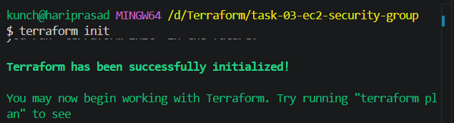
Then:
terraform fmt
Then:
terraform validate
Expected:
Success! The configuration is valid.
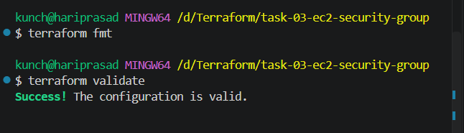

Step 7 — Run Plan
terraform plan
You should see approximately:
Plan: 2 to add, 0 to change, 0 to destroy.
The two resources are:
aws_security_group.ec2_sg
aws_instance.ec2
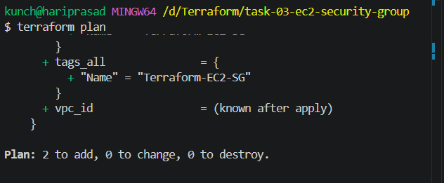

Step 8 — Apply
Run:
terraform apply
When you see:
Do you want to perform these actions?
enter:
yes
Wait for:
Apply complete! Resources: 2 added, 0 changed, 0 destroyed.
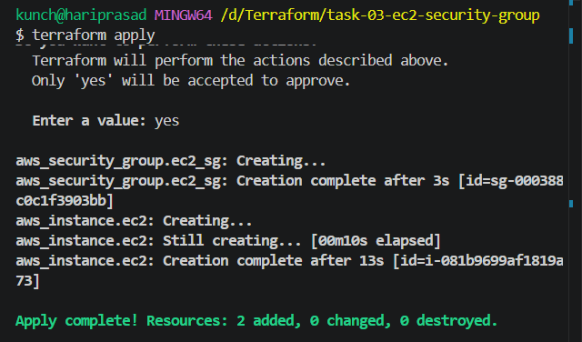

Step 9 — Verify in AWS
Go to:
EC2 → Instances
Find:
Terraform-EC2-Security-Group
Check that it is:
Running
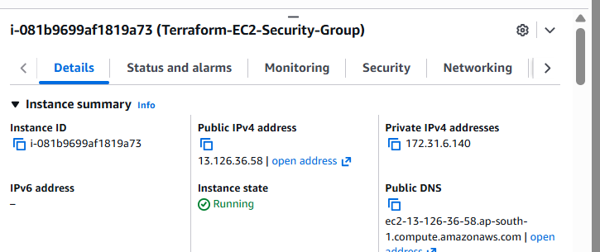
Then go to:
EC2 → Security Groups
You should see:
terraform-ec2-sg
Inbound rules should contain:
Type | Port
SSH | 22
HTTP | 80
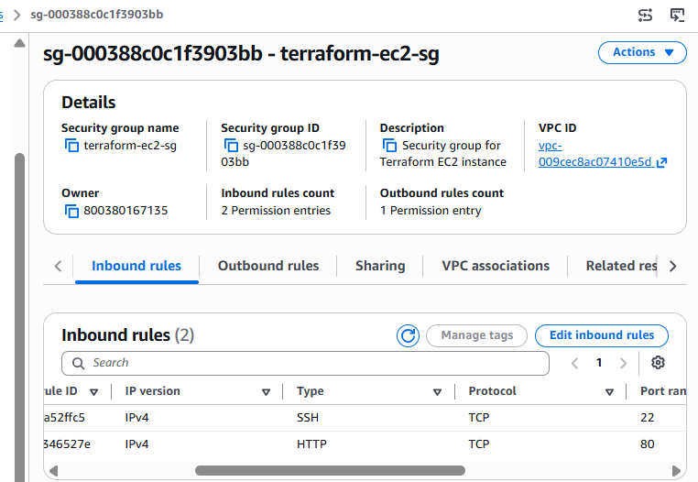

Step 10 — Test HTTP
Copy the EC2 public IPv4 address.
In your browser:
http:// 13.126.36.58
You should see:
Hello from Terraform EC2
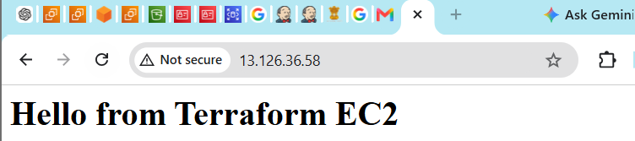

4.Write a Terraform script to create an Application Load Balancer with target groups and EC2 instances.
We’ll build:
Internet
|
v
Application Load Balancer
|
v
Target Group
|
+---- EC2-01
|
+---- EC2-02
Folder
Create:
D:\Terraform\task-04-alb
Files:
task-04-alb/
├── provider.tf
├── variables.tf
├── vpc.tf
├── security-groups.tf
├── instances.tf
├── alb.tf
└── outputs.tf
What we'll create
- VPC
- 2 public subnets in different AZs
- Internet Gateway
- Route table
- 2 EC2 instances
- Security groups
- Application Load Balancer
- Target Group
- Target Group attachments
- HTTP listener

Step 1 — provider.tf
Open provider.tf and paste:
terraform {
required_providers {
aws = {
source = "hashicorp/aws"
}
}
}

provider "aws" {
region = "ap-south-1"
}

Step 2 — variables.tf
Open variables.tf:
variable "region" {
description = "AWS region"
type = string
default = "ap-south-1"
}

variable "ami_id" {
description = "Ubuntu AMI"
type = string
default = "ami-0f918f7e67a3323f0"
}

variable "instance_type" {
description = "EC2 instance type"
type = string
default = "t3.micro"
}

variable "key_name" {
description = "Existing EC2 key pair"
type = string
default = "docker-practice-key"
}
⚠️ If your key pair has a different name, change docker-practice-key to your actual key pair name.

Step 3 — vpc.tf
We'll create our own VPC with two public subnets in two AZs.
Paste:
resource "aws_vpc" "alb_vpc" {
cidr_block = "10.0.0.0/16"
enable_dns_hostnames = true
enable_dns_support = true

tags = {
Name = "Terraform-ALB-VPC"
}
}

resource "aws_internet_gateway" "igw" {
vpc_id = aws_vpc.alb_vpc.id

tags = {
Name = "Terraform-ALB-IGW"
}
}

resource "aws_subnet" "public_1" {
vpc_id = aws_vpc.alb_vpc.id
cidr_block = "10.0.1.0/24"
availability_zone = "ap-south-1a"
map_public_ip_on_launch = true

tags = {
Name = "Terraform-Public-Subnet-1"
}
}

resource "aws_subnet" "public_2" {
vpc_id = aws_vpc.alb_vpc.id
cidr_block = "10.0.2.0/24"
availability_zone = "ap-south-1b"
map_public_ip_on_launch = true

tags = {
Name = "Terraform-Public-Subnet-2"
}
}

resource "aws_route_table" "public" {
vpc_id = aws_vpc.alb_vpc.id

route {
cidr_block = "0.0.0.0/0"
gateway_id = aws_internet_gateway.igw.id
}

tags = {
Name = "Terraform-Public-Route-Table"
}
}

resource "aws_route_table_association" "public_1" {
subnet_id = aws_subnet.public_1.id
route_table_id = aws_route_table.public.id
}

resource "aws_route_table_association" "public_2" {
subnet_id = aws_subnet.public_2.id
route_table_id = aws_route_table.public.id
}
Our network will look like this:
VPC: 10.0.0.0/16
│
├── Public Subnet 1
│ └── ap-south-1a
│ └── EC2-01
│
└── Public Subnet 2
└── ap-south-1b
└── EC2-02
This gives us multi-AZ availability for the ALB.

Step 4 — Check the files
At this point you should have:
task-04-alb/
│
├── provider.tf ✅
├── variables.tf ✅
├── vpc.tf ✅
├── security-groups.tf
├── instances.tf
├── alb.tf
└── outputs.tf
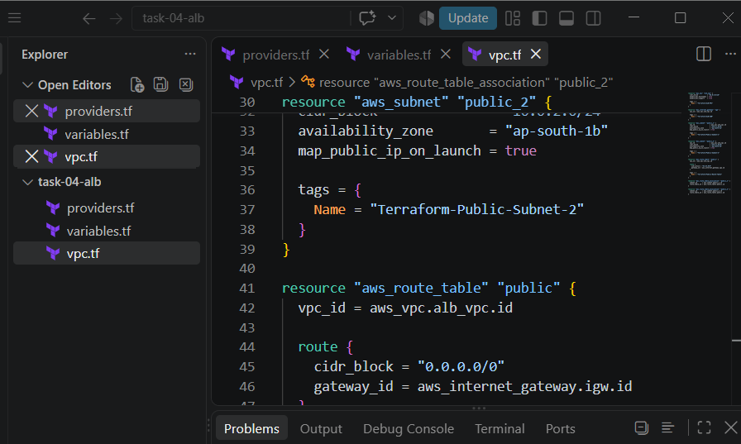
Now run
In VS Code terminal:
terraform init
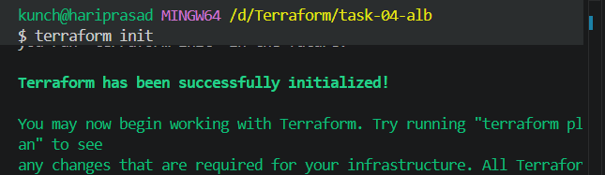
Then:
terraform fmt
Then:
terraform validate
Expected:
Success! The configuration is valid.
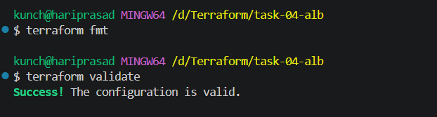

Step 5 — security-groups.tf
Open:
security-groups.tf
Paste this:
resource "aws_security_group" "alb_sg" {
name = "terraform-alb-sg"
description = "Security group for Application Load Balancer"
vpc_id = aws_vpc.alb_vpc.id

ingress {
description = "HTTP from Internet"
from_port = 80
to_port = 80
protocol = "tcp"
cidr_blocks = ["0.0.0.0/0"]
}

egress {
from_port = 0
to_port = 0
protocol = "-1"
cidr_blocks = ["0.0.0.0/0"]
}

tags = {
Name = "Terraform-ALB-SG"
}
}

resource "aws_security_group" "ec2_sg" {
name = "terraform-alb-ec2-sg"
description = "Security group for EC2 instances behind ALB"
vpc_id = aws_vpc.alb_vpc.id

ingress {
description = "HTTP from ALB"
from_port = 80
to_port = 80
protocol = "tcp"
security_groups = [aws_security_group.alb_sg.id]
}

ingress {
description = "SSH"
from_port = 22
to_port = 22
protocol = "tcp"
cidr_blocks = ["0.0.0.0/0"]
}

egress {
from_port = 0
to_port = 0
protocol = "-1"
cidr_blocks = ["0.0.0.0/0"]
}

tags = {
Name = "Terraform-ALB-EC2-SG"
}
}
Why two Security Groups?
Internet
|
| HTTP :80
↓
[ ALB Security Group ]
|
| HTTP :80
↓
[ EC2 Security Group ]
|
├── EC2-01
└── EC2-02
The EC2 instances accept HTTP from the ALB security group, rather than allowing everyone directly.
That's a good real-world architecture.

Step 6 — Validate
Run:
terraform fmt
Then:
terraform validate
Expected:
Success! The configuration is valid.
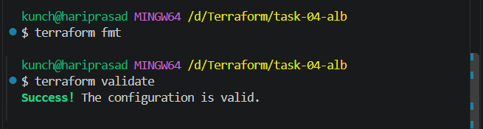
Step 6 — instances.tf
Open:
instances.tf
Paste this:
resource "aws_instance" "web_01" {
ami = var.ami_id
instance_type = var.instance_type
key_name = var.key_name
subnet_id = aws_subnet.public_1.id
vpc_security_group_ids = [aws_security_group.ec2_sg.id]
associate_public_ip_address = true

user_data = <<-EOF
#!/bin/bash
apt update -y
apt install -y apache2
systemctl enable apache2
systemctl start apache2
echo "<h1>Response from Web Server 01</h1>" > /var/www/html/index.html
EOF

tags = {
Name = "Terraform-Web-01"
}
}

resource "aws_instance" "web_02" {
ami = var.ami_id
instance_type = var.instance_type
key_name = var.key_name
subnet_id = aws_subnet.public_2.id
vpc_security_group_ids = [aws_security_group.ec2_sg.id]
associate_public_ip_address = true

user_data = <<-EOF
#!/bin/bash
apt update -y
apt install -y apache2
systemctl enable apache2
systemctl start apache2
echo "<h1>Response from Web Server 02</h1>" > /var/www/html/index.html
EOF

tags = {
Name = "Terraform-Web-02"
}
}
Why apt and apache2?
Your previous EC2 showed:
ubuntu@ip-172-31-6-140
So we're using Ubuntu here:
Ubuntu → apt → apache2
rather than Amazon Linux:
Amazon Linux → dnf → httpd

Step 7 — Create the ALB
Now open:
alb.tf
Paste:
resource "aws_lb" "application_lb" {
name = "terraform-application-alb"
internal = false
load_balancer_type = "application"

security_groups = [
aws_security_group.alb_sg.id
]

subnets = [
aws_subnet.public_1.id,
aws_subnet.public_2.id
]

tags = {
Name = "Terraform-Application-ALB"
}
}

resource "aws_lb_target_group" "web_tg" {
name = "terraform-web-tg"
port = 80
protocol = "HTTP"
vpc_id = aws_vpc.alb_vpc.id

health_check {
enabled = true
healthy_threshold = 2
unhealthy_threshold = 2
timeout = 5
interval = 30
path = "/"
protocol = "HTTP"
matcher = "200"
}

tags = {
Name = "Terraform-Web-Target-Group"
}
}

resource "aws_lb_target_group_attachment" "web_01" {
target_group_arn = aws_lb_target_group.web_tg.arn
target_id = aws_instance.web_01.id
port = 80
}

resource "aws_lb_target_group_attachment" "web_02" {
target_group_arn = aws_lb_target_group.web_tg.arn
target_id = aws_instance.web_02.id
port = 80
}

resource "aws_lb_listener" "http" {
load_balancer_arn = aws_lb.application_lb.arn
port = 80
protocol = "HTTP"

default_action {
type = "forward"
target_group_arn = aws_lb_target_group.web_tg.arn
}
}
Our architecture is now:
Internet
|
| :80
↓
┌──────────────────┐
│ Application ALB │
└────────┬─────────┘
|
Target Group
|
┌────────┴────────┐
↓ ↓
EC2 Web-01 EC2 Web-02
ap-south-1a ap-south-1b
| |
Apache Apache

Step 8 — Outputs
Open:
outputs.tf
Paste:
output "alb_dns_name" {
description = "DNS name of the Application Load Balancer"
value = aws_lb.application_lb.dns_name
}

output "web_01_instance_id" {
value = aws_instance.web_01.id
}

output "web_02_instance_id" {
value = aws_instance.web_02.id
}

output "target_group_arn" {
value = aws_lb_target_group.web_tg.arn
}

output "vpc_id" {
value = aws_vpc.alb_vpc.id
}

Step 9 — Validate everything
Run:
terraform fmt
Then:
terraform validate
Expected:
Success! The configuration is valid.
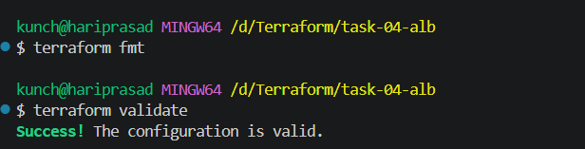
Then run:
terraform plan
This time Terraform should show approximately:
Plan: 11 to add, 0 to change, 0 to destroy.
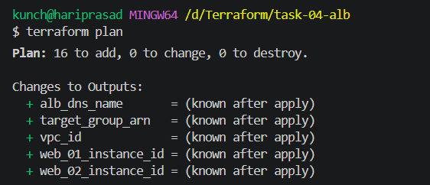
Step 10 — Apply 🚀
Now run:
terraform apply
Terraform will ask:
Do you want to perform these actions?
Only 'yes' will be accepted to approve.
Enter:
yes
What to expect
It may take a few minutes because Terraform needs to create the VPC, networking, EC2s, ALB, target group, and listener.
At the end, you should get something like:
Apply complete! Resources: 16 added, 0 changed, 0 destroyed.

Outputs:

alb_dns_name = "terraform-application-alb-xxxxxxxx.ap-south-1.elb.amazonaws.com"
target_group_arn = "..."
vpc_id = "vpc-..."
web_01_instance_id = "i-..."
web_02_instance_id = "i-..."
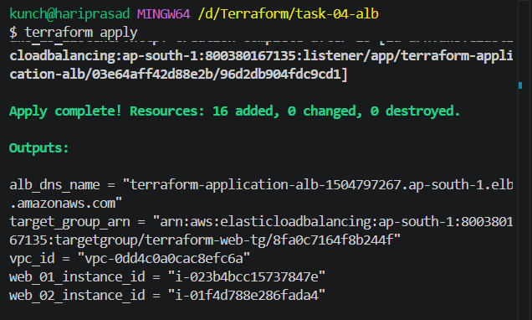
TEST:
Step 1 — Test the ALB
Open this in your browser:
http://terraform-application-alb-1504797267.ap-south-1.elb.amazonaws.com
You should get either:
Response from Web Server 01
or:
Response from Web Server 02
Refresh the page several times. You may see the response switch between the two servers.
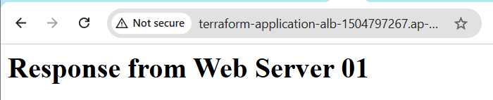
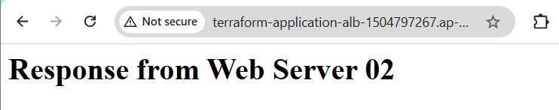
Step 2 — Check Target Health
AWS Console:
EC2 → Load Balancers → terraform-application-alb
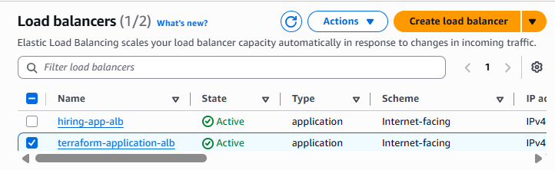
Then:
Target groups → terraform-web-tg → Targets
You want:
Web-01 healthy
Web-02 healthy
The target group is configured with an HTTP health check on / expecting HTTP 200.
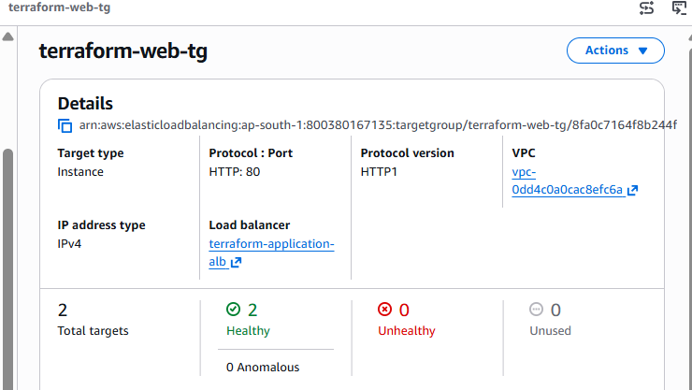

5.Write a Terraform script to create an Auto Scaling Group with a Launch Template.
What we will build
Internet
|
|
Application Load Balancer
|
Target Group :80
|
┌──────────────┴──────────────┐
| |
EC2 Instance EC2 Instance
ASG-managed ASG-managed
| |
Apache Web Server Apache Web Server
| |
└──────────────┬──────────────┘
|
Auto Scaling Group
|
Launch Template
Requirements
We will create:
- VPC
- Internet Gateway
- 2 public subnets
- Route table
- Security Groups
- Launch Template
- Auto Scaling Group
- Minimum 2 instances
- Desired 2 instances
- Maximum 4 instances
- Apache installed automatically
- ALB
- Target Group
- ALB Listener
- ASG automatically registers instances with Target Group

Step 1 — Create the folder
In VS Code:
D:\Terraform\task-05-auto-scaling
Open it:
cd /d D:\Terraform\task-05-auto-scaling
Your final folder will look like:
task-05-auto-scaling/
│
├── provider.tf
├── variables.tf
├── vpc.tf
├── security-groups.tf
├── launch-template.tf
├── autoscaling.tf
├── alb.tf
└── outputs.tf

Step 2 — Create provider.tf
Create:
provider.tf
Put:
terraform {
required_providers {
aws = {
source = "hashicorp/aws"
}
}
}

provider "aws" {
region = var.region
}

Step 3 — Create variables.tf
Create:
variables.tf
Put:
variable "region" {
description = "AWS region"
type = string
default = "ap-south-1"
}

variable "ami_id" {
description = "Ubuntu AMI"
type = string
default = "ami-0f918f7e67a3323f0"
}

variable "instance_type" {
description = "EC2 instance type"
type = string
default = "t3.micro"
}

variable "key_name" {
description = "Existing EC2 key pair"
type = string
default = "docker-practice-key"
}

Step 4 — Create VPC
Create:
vpc.tf
Put:
resource "aws_vpc" "asg_vpc" {
cidr_block = "10.0.0.0/16"
enable_dns_support = true
enable_dns_hostnames = true

tags = {
Name = "Terraform-ASG-VPC"
}
}

resource "aws_internet_gateway" "asg_igw" {
vpc_id = aws_vpc.asg_vpc.id

tags = {
Name = "Terraform-ASG-IGW"
}
}

resource "aws_subnet" "public_1" {
vpc_id = aws_vpc.asg_vpc.id
cidr_block = "10.0.1.0/24"
availability_zone = "ap-south-1a"
map_public_ip_on_launch = true

tags = {
Name = "Terraform-ASG-Public-Subnet-1"
}
}

resource "aws_subnet" "public_2" {
vpc_id = aws_vpc.asg_vpc.id
cidr_block = "10.0.2.0/24"
availability_zone = "ap-south-1b"
map_public_ip_on_launch = true

tags = {
Name = "Terraform-ASG-Public-Subnet-2"
}
}

resource "aws_route_table" "public" {
vpc_id = aws_vpc.asg_vpc.id

route {
cidr_block = "0.0.0.0/0"
gateway_id = aws_internet_gateway.asg_igw.id
}

tags = {
Name = "Terraform-ASG-Public-RT"
}
}

resource "aws_route_table_association" "public_1" {
subnet_id = aws_subnet.public_1.id
route_table_id = aws_route_table.public.id
}

resource "aws_route_table_association" "public_2" {
subnet_id = aws_subnet.public_2.id
route_table_id = aws_route_table.public.id
}

Step 5 — Create Security Groups
Create:
security-groups.tf
Put:
resource "aws_security_group" "alb_sg" {
name = "terraform-asg-alb-sg"
description = "Security group for ASG Application Load Balancer"
vpc_id = aws_vpc.asg_vpc.id

ingress {
description = "HTTP from Internet"
from_port = 80
to_port = 80
protocol = "tcp"
cidr_blocks = ["0.0.0.0/0"]
}

egress {
description = "Allow all outbound traffic"
from_port = 0
to_port = 0
protocol = "-1"
cidr_blocks = ["0.0.0.0/0"]
}

tags = {
Name = "Terraform-ASG-ALB-SG"
}
}

resource "aws_security_group" "ec2_sg" {
name = "terraform-asg-ec2-sg"
description = "Security group for ASG EC2 instances"
vpc_id = aws_vpc.asg_vpc.id

ingress {
description = "HTTP from ALB"
from_port = 80
to_port = 80
protocol = "tcp"
security_groups = [aws_security_group.alb_sg.id]
}

ingress {
description = "SSH"
from_port = 22
to_port = 22
protocol = "tcp"
cidr_blocks = ["0.0.0.0/0"]
}

egress {
description = "Allow all outbound traffic"
from_port = 0
to_port = 0
protocol = "-1"
cidr_blocks = ["0.0.0.0/0"]
}

tags = {
Name = "Terraform-ASG-EC2-SG"
}
}

Step 6 — Create Launch Template
This is the most important part.
The Launch Template tells AWS:
Whenever ASG needs a new EC2, create it using these settings.
Create:
launch-template.tf
Put:
resource "aws_launch_template" "web" {
name_prefix = "terraform-asg-web-"
image_id = var.ami_id
instance_type = var.instance_type
key_name = var.key_name

vpc_security_group_ids = [
aws_security_group.ec2_sg.id
]

user_data = base64encode(<<-EOF
#!/bin/bash

apt update -y
apt install -y apache2

systemctl enable apache2
systemctl start apache2

INSTANCE_ID=$(curl -s http://169.254.169.254/latest/meta-data/instance-id)

echo "<html>
<head>
<title>Terraform Auto Scaling</title>
</head>
<body>
<h1>Terraform Auto Scaling Web Server</h1>
<h2>Instance ID: $INSTANCE_ID</h2>
<p>This server was created by Auto Scaling Group.</p>
</body>
</html>" > /var/www/html/index.html
EOF
)

tag_specifications {
resource_type = "instance"

tags = {
Name = "Terraform-ASG-Web-Server"
}
}

lifecycle {
create_before_destroy = true
}
}
Important concept
The flow is:
Launch Template
|
↓
Auto Scaling Group
|
↓
EC2 Instances
If an instance fails:
Failed EC2
↓
ASG detects failure
↓
ASG terminates/replaces it
↓
Launch Template creates new EC2

Step 7 — Create Auto Scaling Group
Create:
autoscaling.tf
Put:
resource "aws_autoscaling_group" "web" {
name = "terraform-web-asg"

min_size = 2
desired_capacity = 2
max_size = 4

vpc_zone_identifier = [
aws_subnet.public_1.id,
aws_subnet.public_2.id
]

target_group_arns = [
aws_lb_target_group.web_tg.arn
]

health_check_type = "ELB"
health_check_grace_period = 120

launch_template {
id = aws_launch_template.web.id
version = "$Latest"
}

tag {
key = "Name"
value = "Terraform-ASG-Web-Server"
propagate_at_launch = true
}

lifecycle {
create_before_destroy = true
}
}
What these values mean
min_size = 2
ASG will never intentionally go below 2 instances.
desired_capacity = 2
Initially create 2 EC2 instances.
max_size = 4
ASG can scale up to 4 EC2 instances.

Step 8 — Create Application Load Balancer
Create:
alb.tf
Put:
resource "aws_lb" "application_lb" {
name = "terraform-asg-alb"
internal = false
load_balancer_type = "application"

security_groups = [
aws_security_group.alb_sg.id
]

subnets = [
aws_subnet.public_1.id,
aws_subnet.public_2.id
]

tags = {
Name = "Terraform-ASG-ALB"
}
}

resource "aws_lb_target_group" "web_tg" {
name = "terraform-asg-tg"
port = 80
protocol = "HTTP"
vpc_id = aws_vpc.asg_vpc.id

target_type = "instance"

health_check {
enabled = true
path = "/"
protocol = "HTTP"
matcher = "200"
interval = 30
timeout = 5
healthy_threshold = 2
unhealthy_threshold = 2
}

tags = {
Name = "Terraform-ASG-TG"
}
}

resource "aws_lb_listener" "http" {
load_balancer_arn = aws_lb.application_lb.arn
port = 80
protocol = "HTTP"

default_action {
type = "forward"

forward {
target_group {
arn = aws_lb_target_group.web_tg.arn
}
}
}
}
Important difference from Task 4
In Task 4 we manually attached:
EC2-01 → Target Group
EC2-02 → Target Group
In Task 5, we don't manually attach EC2 instances.
Instead:
ASG
↓
Target Group
↓
Automatically register EC2
That's one of the key concepts you should know for interviews.

Step 9 — Create Outputs
Create:
outputs.tf
Put:
output "alb_dns_name" {
description = "Application Load Balancer DNS"
value = aws_lb.application_lb.dns_name
}

output "autoscaling_group_name" {
description = "Auto Scaling Group name"
value = aws_autoscaling_group.web.name
}

output "launch_template_id" {
description = "Launch Template ID"
value = aws_launch_template.web.id
}

output "target_group_arn" {
description = "Target Group ARN"
value = aws_lb_target_group.web_tg.arn
}

output "vpc_id" {
description = "VPC ID"
value = aws_vpc.asg_vpc.id
}

Step 10 — Verify all files
Your VS Code Explorer should look like:
📁 task-05-auto-scaling
│
├── 📄 provider.tf
├── 📄 variables.tf
├── 📄 vpc.tf
├── 📄 security-groups.tf
├── 📄 launch-template.tf
├── 📄 autoscaling.tf
├── 📄 alb.tf
└── 📄 outputs.tf
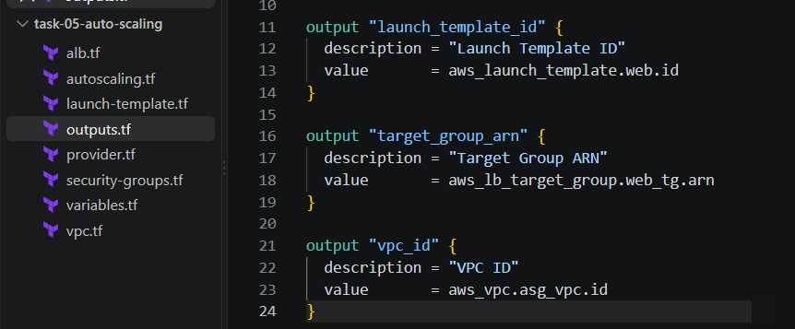

Step 11 — Terraform Init
Open Git Bash:
cd /d D:\Terraform\task-05-auto-scaling
Run:
terraform init
Expected:
Terraform has been successfully initialized!
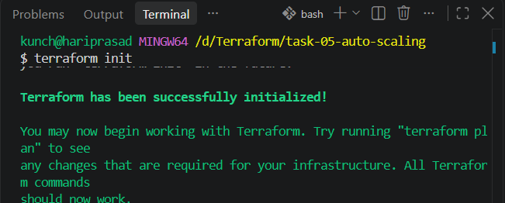

Step 12 — Terraform Format
Run:
terraform fmt
You should see the .tf files formatted.

Step 13 — Terraform Validate
Run:
terraform validate
Expected:
Success! The configuration is valid.
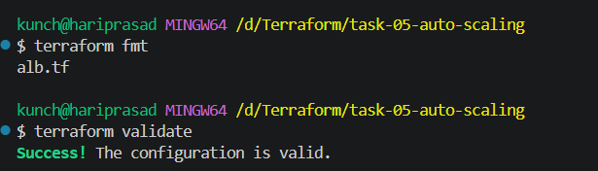

Step 14 — Terraform Plan
Run:
terraform plan
You should see resources being created.
Approximately:
Plan: 13 to add, 0 to change, 0 to destroy.
The exact number can vary slightly with provider behavior.
Do not worry if the number is different.
The important resources should include:
aws_vpc
aws_internet_gateway
aws_subnet.public_1
aws_subnet.public_2
aws_route_table
aws_route_table_association
aws_security_group.alb_sg
aws_security_group.ec2_sg
aws_launch_template.web
aws_autoscaling_group.web
aws_lb.application_lb
aws_lb_target_group.web_tg
aws_lb_listener.http
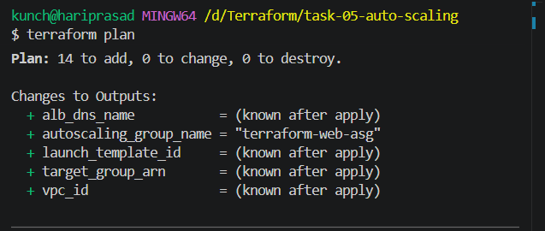

Step 15 — Apply
Now run:
terraform apply
Terraform will ask:
Do you want to perform these actions?
Only 'yes' will be accepted to approve.
Enter:
yes
Wait for completion.

Step 16 — Check Terraform Outputs
After successful apply, run:
terraform output
You should get something similar to:
alb_dns_name = "terraform-asg-alb-xxxxxxxx.ap-south-1.elb.amazonaws.com"

autoscaling_group_name = "terraform-web-asg"

launch_template_id = "lt-xxxxxxxxxxxxxxxxx"

target_group_arn = "arn:aws:elasticloadbalancing:..."

vpc_id = "vpc-xxxxxxxxxxxxxxxxx"
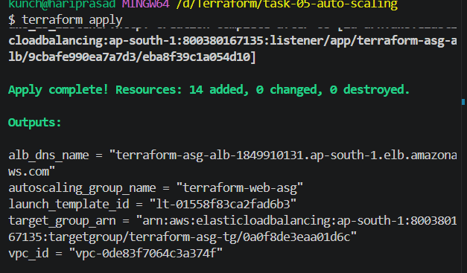

Step 17 — Test the ALB
Copy the DNS name.
For example:
terraform-asg-alb-xxxxxxxx.ap-south-1.elb.amazonaws.com
Open:
http://terraform-asg-alb-1849910131.ap-south-1.elb.amazonaws.com
You should see:
Terraform Auto Scaling Web Server

Instance ID: i-xxxxxxxxxxxxxxxxx

This server was created by Auto Scaling Group.
Refresh several times.
The Instance ID can change, because the ALB distributes requests across the ASG instances.
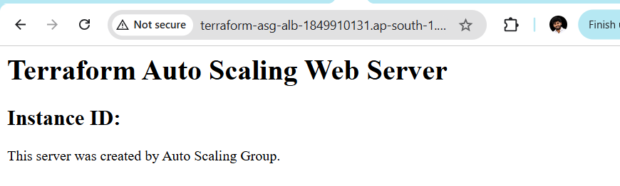
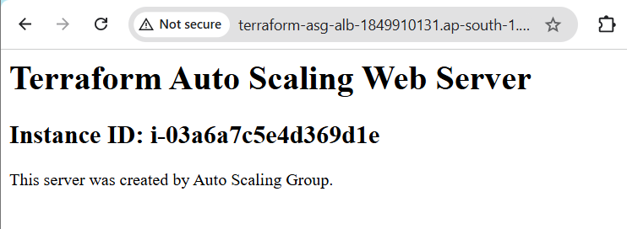

Step 18 — Check ASG in AWS Console
Go to:
AWS Console → EC2 → Auto Scaling Groups
Find:
terraform-web-asg
You should see:
Desired capacity: 2
Min: 2
Max: 4
And:
Instances: 2
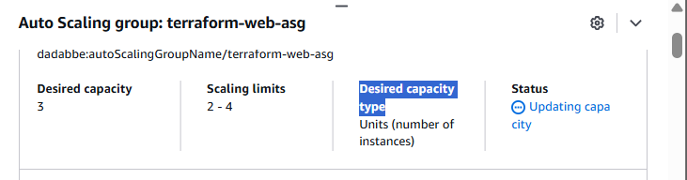

Step 19 — Check the two AZs
The ASG should use:
ap-south-1a
ap-south-1b
So ideally:
ASG
│
├── ap-south-1a
│ └── EC2
│
└── ap-south-1b
└── EC2
This gives you basic high availability across two Availability Zones.
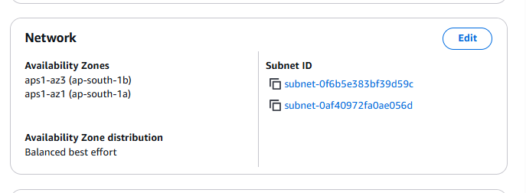

Step 20 — Check Target Group
Go to:
EC2 → Target Groups
Open:
terraform-asg-tg
Go to:
Targets
You should see:
Instance ID Status
--------------------------------
i-xxxxxxxxxxxx Healthy
i-yyyyyyyyyyyy Healthy
Wait until both become:
Healthy
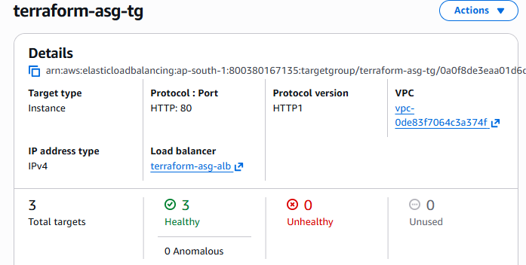

Step 21 — VERY IMPORTANT: Test Auto Scaling
Now we are going to prove that the ASG actually works.
Go to:
EC2 → Auto Scaling Groups → terraform-web-asg
Choose:
Edit
Change:
Desired capacity:
2 → 3
Keep:
Minimum: 2
Maximum: 4
Save.
AWS should create another EC2.
You should eventually have:
EC2 #1
EC2 #2
EC2 #3
And Target Group should eventually show:
3 Healthy targets

Step 22 — Test Scale Down
Change:
Desired capacity:
3 → 2
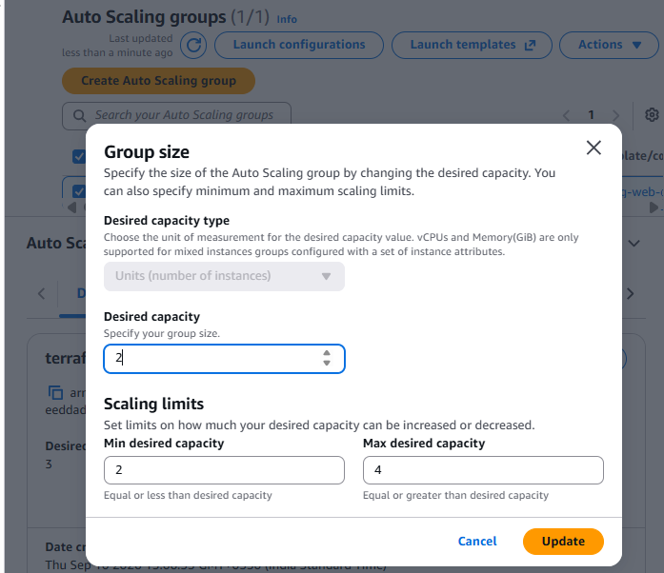
AWS should terminate one instance.
Eventually:
EC2 #1
EC2 #2
This demonstrates:
Scale Out
2 → 3
and:
Scale In
3 → 2

Step 23 — Understand the Architecture
For your interview, remember this:
Internet
|
↓
Application LB
|
↓
Target Group
|
↓
Auto Scaling Group
|
┌─────────┴─────────┐
↓ ↓
EC2 Instance EC2 Instance
ap-south-1a ap-south-1b
↑ ↑
└──── Launch Template
Launch Template
Defines:
AMI
Instance Type
Key Pair
Security Group
User Data
Tags
Auto Scaling Group
Defines:
Minimum instances
Desired instances
Maximum instances
Subnets/AZs
Health checks
Launch Template
Target Group
Target Group
Defines:
Which instances receive ALB traffic

6.Write a Terraform script to create multiple resources using for_each with a map variable.
Goal
We will configure Terraform to store its state file remotely in Amazon S3 instead of keeping:
terraform.tfstate
only on your local computer.
Architecture:
VS Code / Git Bash
|
| terraform apply
↓
AWS Resources
|
↓
Terraform State
|
↓
S3
This is an important real-world Terraform concept because teams normally use a remote backend rather than keeping the state file only on a developer's laptop.

Step 1 — Create a new folder
Create:
D:\Terraform\task-06-s3-backend
Open Git Bash:
cd /d D:\Terraform/task-06-s3-backend
Your folder will initially contain:
task-06-s3-backend/

Step 2 — Create the S3 bucket first
⚠️ Important:
The S3 bucket used as the Terraform backend must exist before terraform init can configure the S3 backend.
We'll create the bucket separately first.
You can use the AWS Console, but since we're practicing Terraform, let's use AWS CLI.
Run:
aws sts get-caller-identity
You should see your AWS account information.
Then create a globally unique bucket:
aws s3api create-bucket \
--bucket venu-terraform-state-800380167135 \
--region ap-south-1 \
--create-bucket-configuration LocationConstraint=ap-south-1
Expected:
{
"Location": "..."
}
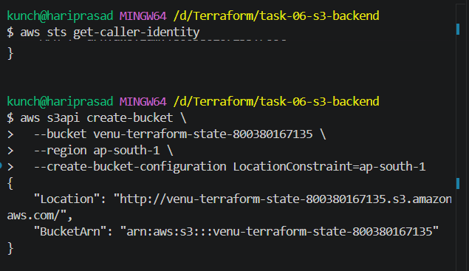

Step 3 — Enable bucket versioning
This is strongly recommended for Terraform state.
Run:
aws s3api put-bucket-versioning \
--bucket venu-terraform-state-800380167135 \
--versioning-configuration Status=Enabled
Verify:
aws s3api get-bucket-versioning \
--bucket venu-terraform-state-800380167135
Expected:
{
"Status": "Enabled"
}
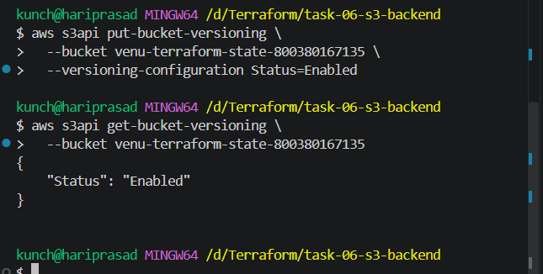

Step 4 — Enable S3 encryption
Run:
aws s3api put-bucket-encryption \
--bucket venu-terraform-state-800380167135 \
--server-side-encryption-configuration '{
"Rules": [
{
"ApplyServerSideEncryptionByDefault": {
"SSEAlgorithm": "AES256"
}
}
]
}'
This ensures Terraform state is encrypted at rest in S3.

Step 5 — Block public access
Very important because Terraform state can contain sensitive information.
Run:
aws s3api put-public-access-block \
--bucket venu-terraform-state-800380167135 \
--public-access-block-configuration \
BlockPublicAcls=true,IgnorePublicAcls=true,BlockPublicPolicy=true,RestrictPublicBuckets=true
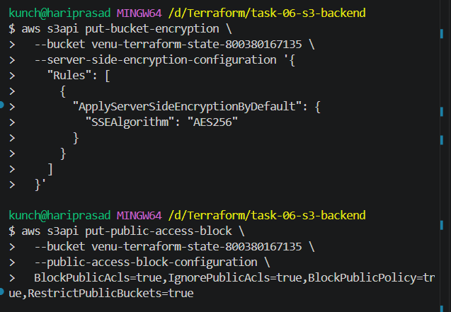

Step 6 — Verify the bucket
Run:
aws s3api head-bucket \
--bucket venu-terraform-state-800380167135
If there is no error, the bucket exists and is accessible.
Also run:
aws s3 ls
You should see:
venu-terraform-state-800380167135
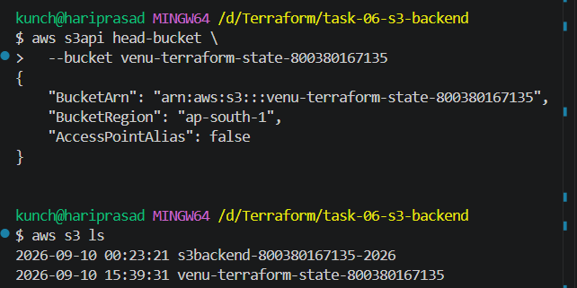

Step 7 — Create a Terraform configuration
Now create:
main.tf
For this task, we'll create a simple S3 bucket as the Terraform-managed resource.
Put this in main.tf:
terraform {
required_providers {
aws = {
source = "hashicorp/aws"
}
}
}

provider "aws" {
region = "ap-south-1"
}

resource "aws_s3_bucket" "demo" {
bucket = "venu-terraform-backend-demo-800380167135"

tags = {
Name = "Terraform Backend Demo"
Environment = "Practice"
}
}

Step 8 — Create backend.tf
Create:
backend.tf
Put:
terraform {
backend "s3" {
bucket = "venu-terraform-state-800380167135"
key = "task-06/terraform.tfstate"
region = "ap-south-1"
use_lockfile = true
encrypt = true
}
}
Understand this carefully
bucket = "venu-terraform-state-800380167135"
This is where Terraform stores the state.
key = "task-06/terraform.tfstate"
This is the path/name of the state file inside S3.
So your S3 bucket will eventually look like:
venu-terraform-state-800380167135
│
└── task-06/
└── terraform.tfstate
use_lockfile = true
This enables Terraform's S3 state-locking mechanism using a lock file.
Note: This is the modern S3 backend locking approach. We don't need to create a DynamoDB table for this task.

Step 9 — Initialize Terraform
Now run:
terraform init
Terraform should detect the S3 backend.
You should see something similar to:
Initializing the backend...

Successfully configured the backend "s3"!

Terraform has been successfully initialized!
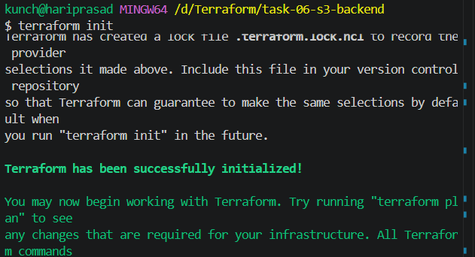

Step 10 — Verify the backend
Run:
terraform plan
Then:
terraform apply
Enter:
yes
Terraform should create:
aws_s3_bucket.demo
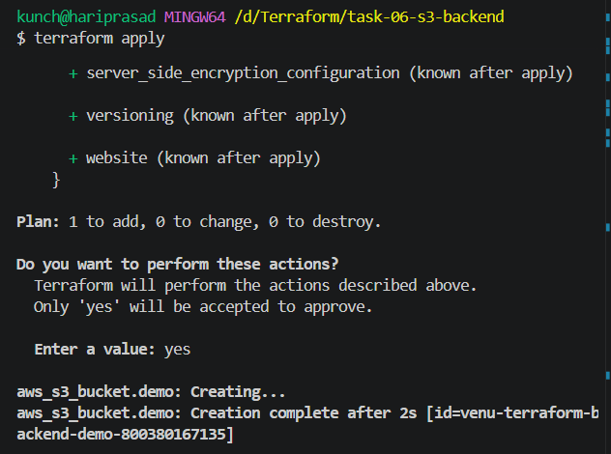

Step 11 — Verify state in S3
Run:
aws s3 ls s3://venu-terraform-state-800380167135/task-06/
You should see:
terraform.tfstate
🎉 That's the proof that Terraform is now using S3 as the backend.
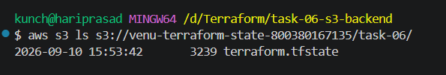

Step 12 — Verify locally
Run:
ls
You should have:
backend.tf
main.tf
.terraform/
.terraform.lock.hcl
Depending on Terraform behavior, you should not rely on a local terraform.tfstate file being present—the state is now managed remotely.
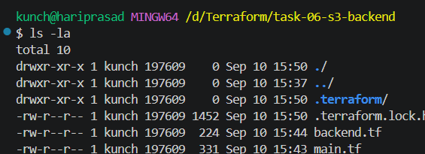

🧠 Understand the difference
Before S3 backend
Your computer
│
├── main.tf
├── terraform.tfstate
└── terraform.tfstate.backup
After S3 backend
Your computer
│
├── main.tf
├── backend.tf
└── .terraform/

↓
↓
AWS S3 Bucket
│
└── task-06/
└── terraform.tfstate

7.Write a Terraform script using variables, terraform.tfvars, and output values.
We’ll create a simple EC2 instance using:
- variables.tf → variable definitions
- terraform.tfvars → actual variable values
- main.tf → EC2 resource
- outputs.tf → display useful information
Step 1: Create the folder
In VS Code, create:
Terraform-07-Variables
Inside it, create these 4 files:
Terraform-07-Variables/
├── main.tf
├── variables.tf
├── terraform.tfvars
└── outputs.tf

Step 2: Create variables.tf
variable "aws_region" {
description = "AWS region"
type = string
}

variable "instance_type" {
description = "EC2 instance type"
type = string
}

variable "instance_name" {
description = "Name of the EC2 instance"
type = string
}

variable "ami_id" {
description = "AMI ID for EC2"
type = string
}
Here we are declaring variables.

Step 3: Create terraform.tfvars
Since you're working in Mumbai, use your Mumbai AMI ID.
aws_region = "ap-south-1"
instance_type = "t3.micro"
instance_name = "Terraform-Variables-Server"
ami_id = "YOUR_AMI_ID"
Replace:
YOUR_AMI_ID
with a valid Amazon Linux AMI ID from your Mumbai region.
For example:
ami_id = "ami-xxxxxxxxxxxxxxxxx"
Don't copy an AMI ID from a different region.

Step 4: Create main.tf
provider "aws" {
region = var.aws_region
}

resource "aws_instance" "webserver" {
ami = var.ami_id
instance_type = var.instance_type

tags = {
Name = var.instance_name
}
}
Notice how we are using:
var.aws_region
var.ami_id
var.instance_type
var.instance_name
The values come from terraform.tfvars.

Step 5: Create outputs.tf
output "instance_id" {
description = "EC2 Instance ID"
value = aws_instance.webserver.id
}

output "public_ip" {
description = "Public IP address"
value = aws_instance.webserver.public_ip
}

output "instance_name" {
description = "EC2 Instance Name"
value = aws_instance.webserver.tags["Name"]
}
These will show information after terraform apply.

Step 6: Initialize Terraform
Open the VS Code terminal:
cd Terraform-07-Variables
Then:
terraform init
You should see:
Terraform has been successfully initialized!
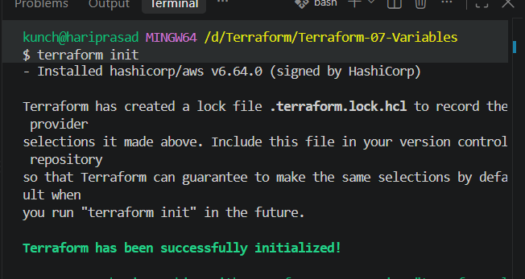

Step 7: Validate
terraform validate
Expected:
Success! The configuration is valid.
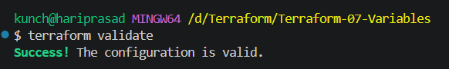

Step 8: Format
terraform fmt

Step 9: Create the plan
terraform plan
Terraform will read the values from:
terraform.tfvars
and show that it will create:
aws_instance.webserver
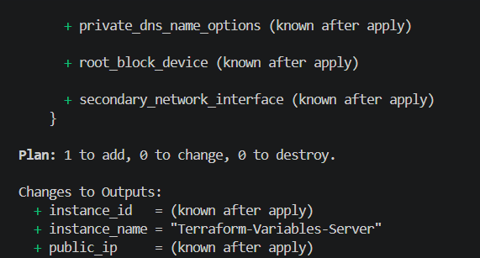

Step 10: Apply
terraform apply
Enter:
yes
After successful creation, you should see something similar to:
Outputs:

instance_id = "i-xxxxxxxxxxxxxxxxx"
instance_name = "Terraform-Variables-Server"
public_ip = "13.xx.xx.xx"
🎯 This completes the requirement: variables + terraform.tfvars + output values.
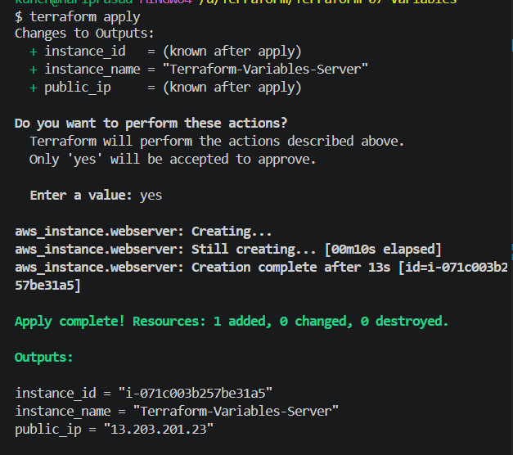

Step 11: Check outputs anytime
After the instance is created:
terraform output
Or individually:
terraform output instance_id
terraform output public_ip
terraform output instance_name

Step 12: Destroy after testing
If this is only a lab and you don't need the EC2 instance:
terraform destroy
Enter:
Yes
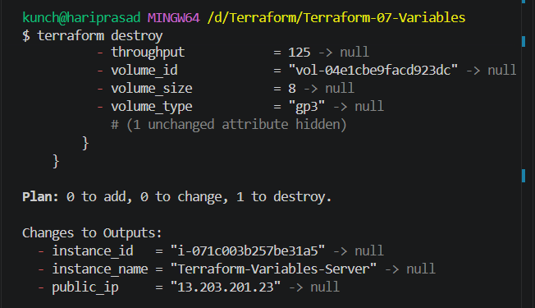
Final project structure
Terraform-07-Variables/
│
├── main.tf
├── variables.tf
├── terraform.tfvars
└── outputs.tf

8.Write a Terraform script using conditional expressions to create resources based on an environment variable.
Objective
We will create an EC2 instance only when the environment is prod.
For example:
environment = "dev" → No EC2 instance
environment = "prod" → Create EC2 instance
We'll use Terraform's conditional expression:
count = var.environment == "prod" ? 1 : 0

Step 1: Create the folder
In VS Code create:
Terraform-08-Conditional
Inside it:
Terraform-08-Conditional/
├── main.tf
├── variables.tf
├── terraform.tfvars
└── outputs.tf

Step 2: Create variables.tf
variable "aws_region" {
description = "AWS region"
type = string
}

variable "environment" {
description = "Deployment environment"
type = string
}

variable "ami_id" {
description = "AMI ID"
type = string
}

variable "instance_type" {
description = "EC2 instance type"
type = string
}

Step 3: Create terraform.tfvars
Use your Mumbai region:
aws_region = "ap-south-1"
environment = "prod"
ami_id = "YOUR_AMI_ID"
instance_type = "t3.micro"
Replace:
YOUR_AMI_ID
with your valid Amazon Linux AMI ID from ap-south-1.

Step 4: Create main.tf
provider "aws" {
region = var.aws_region
}

resource "aws_instance" "webserver" {
count = var.environment == "prod" ? 1 : 0

ami = var.ami_id
instance_type = var.instance_type

tags = {
Name = "Terraform-${var.environment}-Server"
Environment = var.environment
}
}
Most important line 👇
count = var.environment == "prod" ? 1 : 0
This means:
IF environment == "prod"
create 1 instance
ELSE
create 0 instances
This is Terraform's conditional expression.

Step 5: Create outputs.tf
Because we're using count, we need to reference the resource with [0].
output "instance_id" {
description = "EC2 Instance ID"
value = var.environment == "prod" ? aws_instance.webserver[0].id : "No instance created"
}

output "environment" {
description = "Current environment"
value = var.environment
}

Step 6: Initialize Terraform
Open VS Code terminal:
cd Terraform-08-Conditional
Then:
terraform init
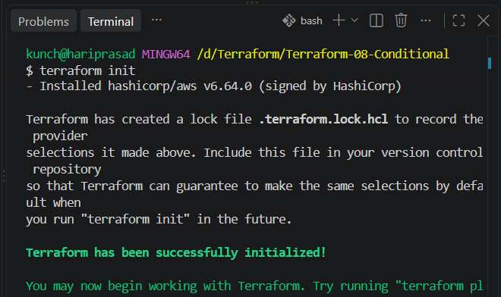

Step 7: Validate
terraform validate
Expected:
Success! The configuration is valid.
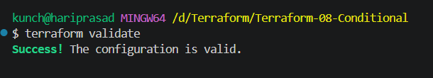

Step 8: Format
terraform fmt

Step 9: Test with prod
Currently your terraform.tfvars contains:
environment = "prod"
Run:
terraform plan
You should see:
Plan: 1 to add, 0 to change, 0 to destroy.
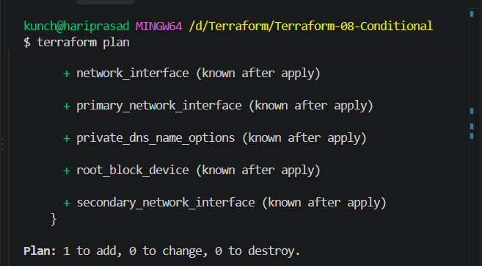
Then:
terraform apply
Enter:
yes
Terraform creates the EC2 instance.
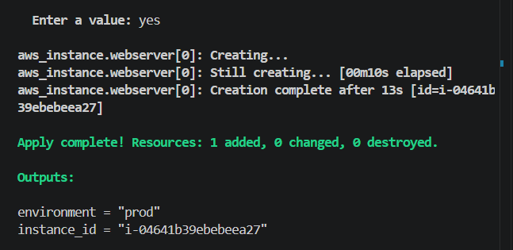

Step 10: Test with dev
Now change:
environment = "prod"
to:
environment = "dev"
Run:
terraform plan
Now Terraform should show that the production instance will be destroyed because the condition becomes false:
Plan: 0 to add, 0 to change, 1 to destroy.
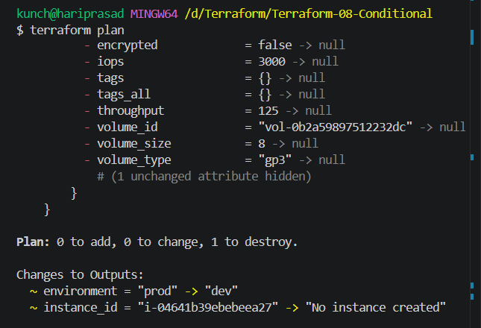
If you apply:
terraform apply
the EC2 instance will be removed.
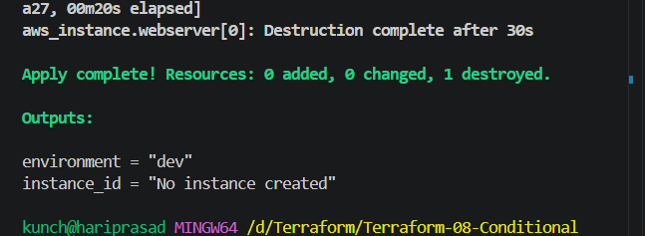

⭐ Better way to understand it
Think of this:
count = var.environment == "prod" ? 1 : 0
as:
environment
│
┌────────┴────────┐
│ │
prod dev
│ │
▼ ▼
count = 1 count = 0
│ │
▼ ▼
Create EC2 Don't create EC2

9. Explain the difference between count and for_each. When would you use each?
Both are used to create multiple instances of a resource.
count
Use count when you have a simple number of identical resources.
resource "aws_instance" "server" {
count = 3

ami = var.ami_id
instance_type = "t3.micro"

tags = {
Name = "Server-${count.index}"
}
}
This creates:
Server-0
Server-1
Server-2
Resources are referenced using:
aws_instance.server[0]
aws_instance.server[1]
aws_instance.server[2]
for_each
Use for_each when each resource needs a different name or value.
variable "servers" {
default = {
web = "t3.micro"
app = "t3.small"
db = "t3.medium"
}
}

resource "aws_instance" "server" {
for_each = var.servers

ami = var.ami_id
instance_type = each.value

tags = {
Name = each.key
}
}
Creates:
web → t3.micro
app → t3.small
db → t3.medium
Easy interview answer
count is best when resources are nearly identical and I need a numeric number of instances. for_each is better when each resource has unique keys or values.
count | for_each
Uses number | Uses collection
count.index | each.key, each.value
Good for identical resources | Good for uniquely identified resources
Example: 3 web servers | Example: web/app/db servers

10. Explain the difference between locals, variables, and outputs in Terraform.
These three are very important.
Variables
Variables are inputs to your Terraform configuration.
variable "instance_type" {
type = string
default = "t3.micro"
}
You can provide the value through:
terraform.tfvars
instance_type = "t3.small"
Think:
VARIABLE = INPUT

Locals
Locals are internal reusable values.
locals {
project_name = "myapp"
environment = "dev"

server_name = "${local.project_name}-${local.environment}"
}
Use:
local.server_name
Think:
LOCALS = INTERNAL CALCULATIONS / REUSABLE VALUES

Outputs
Outputs show information after Terraform creates resources.
output "instance_id" {
value = aws_instance.web.id
}
Then:
terraform output
Think:
OUTPUT = RESULT
Easy way to remember
Variable → Input
Local → Internal value
Output → Result

11. What is the purpose of terraform plan and how is it different from terraform apply?
terraform plan
Shows what Terraform wants to do.
terraform plan
For example:
Plan: 2 to add, 0 to change, 0 to destroy.
It does not make the changes.

terraform apply
Actually performs the changes.
terraform apply
Terraform will create/update/delete resources according to the plan.
Simple comparison
terraform plan
↓
Preview changes
↓
terraform apply
↓
Actually make changes
Interview answer
terraform plan creates an execution plan showing the differences between the desired configuration and current state. terraform apply executes those changes against the infrastructure.

12. Explain the Terraform resource lifecycle and the use of create_before_destroy.
Terraform normally follows a lifecycle such as:
Create
↓
Update
↓
Destroy
Terraform determines whether a resource can be updated or must be replaced.
You can customize this using the lifecycle block.
create_before_destroy
Normally Terraform may:
Destroy old resource
↓
Create new resource
With:
lifecycle {
create_before_destroy = true
}
Terraform tries:
Create new resource
↓
Destroy old resource
Example:
resource "aws_instance" "web" {
ami = var.ami_id
instance_type = "t3.micro"

lifecycle {
create_before_destroy = true
}
}
Why use it?
To reduce downtime when replacing resources.
Interview answer
create_before_destroy tells Terraform to create the replacement resource before destroying the existing one, which can help minimize downtime.

13. What is depends_on in Terraform? Give a practical example.
depends_on creates an explicit dependency between resources.
Example:
resource "aws_instance" "web" {
ami = var.ami_id
instance_type = "t3.micro"

depends_on = [
aws_s3_bucket.logs
]
}
This tells Terraform:
Create S3 bucket
↓
Create EC2
Terraform will wait for the S3 bucket before creating the EC2 instance.
Practical example
Suppose your application needs a database before the application server starts:
resource "aws_instance" "app" {
ami = var.ami_id
instance_type = "t3.micro"

depends_on = [
aws_instance.database
]
}
Important
Don't use depends_on unnecessarily.
Terraform can automatically understand many dependencies.

14. What is the difference between implicit and explicit dependencies?
Implicit dependency
Terraform automatically detects the dependency because one resource references another.
Example:
resource "aws_security_group" "web" {
name = "web-sg"
}

resource "aws_instance" "web" {
ami = var.ami_id
instance_type = "t3.micro"

vpc_security_group_ids = [
aws_security_group.web.id
]
}
Terraform sees:
Security Group
↓
EC2 Instance
because:
aws_security_group.web.id
is referenced.
That's an implicit dependency.

Explicit dependency
You manually tell Terraform:
depends_on = [
aws_security_group.web
]
Example:
resource "aws_instance" "web" {
ami = var.ami_id
instance_type = "t3.micro"

depends_on = [
aws_security_group.web
]
}
Easy interview answer
Implicit dependencies are automatically detected from resource references. Explicit dependencies are manually defined using depends_on.

15. Explain Terraform modules. What are root and child modules?
A module is a reusable collection of Terraform configuration files.
Instead of writing the same EC2 code repeatedly, you create a module once and reuse it.
For example:
terraform-project/
│
├── main.tf
│
└── modules/
└── ec2/
├── main.tf
├── variables.tf
└── outputs.tf
The main project is called the:
Root module
The directory where you run:
terraform init
terraform plan
terraform apply
is the root module.
Child module
A module called by another module is a child module.
Example:
module "webserver" {
source = "./modules/ec2"
}
Here:
Root Module
│
▼
Child Module
Why modules?
- Reusability
- Standardization
- Less duplicate code
- Easier maintenance
- Better organization

16. How do you pass variables from a root module to a child module?
Suppose child module has:
modules/ec2/variables.tf
variable "instance_type" {
type = string
}
Root module:
main.tf
module "webserver" {
source = "./modules/ec2"

instance_type = "t3.micro"
}
The flow is:
Root Module
│
│ instance_type = "t3.micro"
▼
Child Module
│
▼
variable "instance_type"
You can also pass a root variable:
variable "instance_type" {
type = string
}

module "webserver" {
source = "./modules/ec2"

instance_type = var.instance_type
}
Then terraform.tfvars:
instance_type = "t3.micro"
So the complete flow is:
terraform.tfvars
↓
Root variable
↓
Child module
↓
Resource

17. How do you pass output values from a child module to the root module?
Suppose child module creates an EC2 instance.
Child module outputs.tf
output "instance_id" {
value = aws_instance.web.id
}
Then root module:
output "webserver_instance_id" {
value = module.webserver.instance_id
}
The flow is:
Child EC2
↓
Child output
↓
Root module
↓
Root output
After:
terraform apply
you might get:
webserver_instance_id = "i-0123456789abcdef"

18. What is the difference between local modules and remote modules?
Local module
Stored on your local machine.
module "webserver" {
source = "./modules/ec2"
}
The module is located inside your Terraform project.
Example:
project/
└── modules/
└── ec2/

Remote module
Stored somewhere outside your project.
For example, Terraform Registry:
module "vpc" {
source = "terraform-aws-modules/vpc/aws"
}
Or a Git repository:
module "webserver" {
source = "git::https://github.com/example/terraform-ec2.git"
}
Comparison
Local | Remote
Local filesystem | Registry/Git/etc.
./modules/ec2 | terraform-aws-modules/...
Good for your own project modules | Good for shared/reusable modules

19. How do you manage different environments such as Dev, QA, and Production using Terraform?
There are several approaches.
A common structure is:
terraform/
│
├── modules/
│ └── ec2/
│
├── environments/
│ ├── dev/
│ │ ├── main.tf
│ │ └── terraform.tfvars
│ │
│ ├── qa/
│ │ ├── main.tf
│ │ └── terraform.tfvars
│ │
│ └── prod/
│ ├── main.tf
│ └── terraform.tfvars
Each environment can use the same module.
EC2 Module
│
┌─────────┼─────────┐
↓ ↓ ↓
Dev QA Prod
For example:
Dev
module "webserver" {
source = "../../modules/ec2"
instance_type = "t3.micro"
}
Production
module "webserver" {
source = "../../modules/ec2"
instance_type = "t3.large"
}
Another approach is Terraform workspaces:
terraform workspace new dev
terraform workspace new qa
terraform workspace new prod
Then:
terraform workspace select dev
or:
terraform workspace select prod
Interview answer
I can manage environments using separate environment directories with reusable modules, separate state files/backends, and environment-specific variable values. Terraform workspaces can also be used when the environments share the same configuration structure.
For real production infrastructure, separate environment configurations/state are often easier to isolate and manage than relying heavily on workspaces.

20. Explain the purpose of .terraform.lock.hcl.
This is a very important Terraform file.
When Terraform downloads providers, such as:
AWS Provider
Terraform records the selected provider version and checksums in:
.terraform.lock.hcl
For example:
.terraform.lock.hcl
It helps ensure that your team gets a consistent provider version.
Example
Suppose your project uses:
AWS Provider 6.x
The lock file records the selected version/checksums.
Another developer runs:
terraform init
Terraform uses the lock file to select the same locked provider version when compatible.
Should you commit it to Git?
Yes.
Normally you should commit:
.terraform.lock.hcl
to your Git repository.
But you normally do not commit:
.terraform/
and you should protect:
*.tfstate
*.tfstate.*
because state can contain sensitive information.
Easy interview answer
.terraform.lock.hcl locks Terraform provider selections and records checksums so that different users and environments use consistent, verified provider packages.

🧠 Super-short interview revision
Memorize these:
9. count vs for_each
count → number/index
for_each → unique keys/values

10. variables vs locals vs outputs
variable → input
local → internal reusable value
output → result

11. plan vs apply
plan → preview
apply → execute

12. create_before_destroy
create replacement first, then destroy old

13. depends_on
manually define dependency

14. implicit vs explicit
implicit → Terraform detects
explicit → depends_on

15. modules
reusable Terraform code
root → main project
child → called module

16. root → child
module argument

17. child → root
module output

18. local vs remote
local filesystem vs Registry/Git

19. environments
dev / qa / prod using modules + separate configurations/state
or workspaces where appropriate

20. .terraform.lock.hcl
locks provider versions/checksums

